Recognize multimedia devices  
**In which picture can you see a GPS**?

* 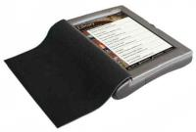
* 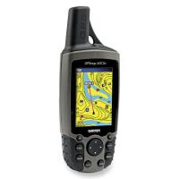
* 

**In which picture can you see a karaoke set**?

* 
* 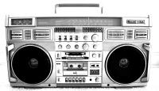
* 

**In which picture can you see an e-book reader**?

* 
* 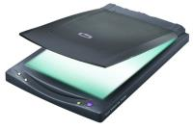
* 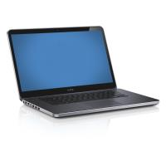

**In which picture can you see a karaoke set**?

* 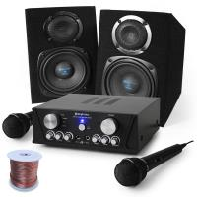
* 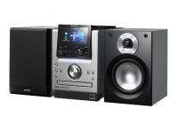
* 

**In which picture can you see a radio**?

* 
* 
* 

**In which picture can you see a CD player**?

* 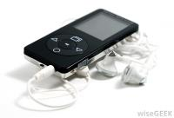
* 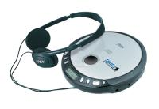
* 

Recognize Multimedia and computer devices  
**In which picture can you see a mp3 player**?

* 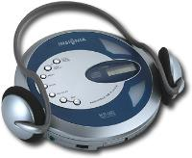
* 
* 

**In which picture can you see a video camera**?

* 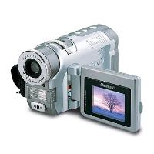
* 
* 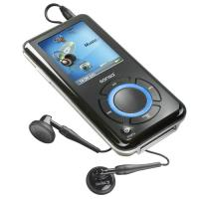

**In which picture can you see a fax machine**?

* 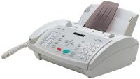
* 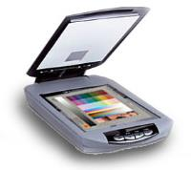
* dvd2.jpg

**In which picture can you see a dictaphone**?

* 
* 
* 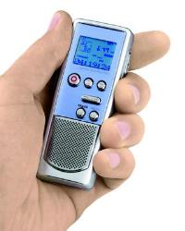

Multimedia and computer devices I  
Начало формы

Write in the right name for the device in the picture below.

|  |  |  |
| --- | --- | --- |
| radio2.jpg | tv2.jpg | camerapng.png |
|  |  |  |

Начало формы

|  |  |  |
| --- | --- | --- |
| memorycard2.jpg | cdplayuer2.jpg | usbpng.png |
|  |  |  |

Начало формы

|  |  |  |
| --- | --- | --- |
| gps.jpg | dictaphone.jpg | laptp2.jpg |
|  |  |  |

Начало формы

|  |  |  |
| --- | --- | --- |
| tablet2.jpg | scanner2.jpg | sony-playstation-3-3ej-800.jpg |
|  |  |  |

Multimedia and computer devices II  
**Choose the name of the device appropriate to the definition.**

What do you need if you want to...

**1.**Store digital information - a) TV b) Stereo c) Memory card

**2.**Make or receive calls - a) Dictaphone b) GPS c) Mobile Phone

**3.**Read books -  a) E-book b) Mouse c) Fax Machine

**4.**Watching TV-shows and movies – a) Play Station b) TV c) Video Camera

**5.**Play video games in handheld console – a) Stereo b) TV c) Play Station **6.**Scan printed images or documents and convert them into digital format –   
 a) Fax machine b) Laptop c) Scanner  
**7.**Control the cursor  - a) Keyboard b) Laptop c) Scanner

Recognize household appliances  
**In which picture can you see a freezer**?

* 
* 
* 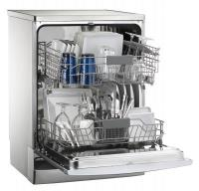

Конец формы

Конец формы

Конец формы

Конец формы

**In which picture can you see a toaster**?

* 
* 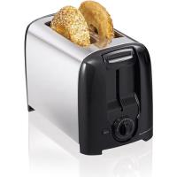
* 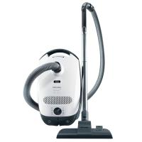

**In which picture can you see an iron**?

* 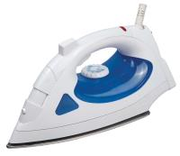
* 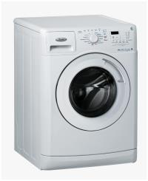
* 

**In which picture can you see a dryer**?

* 
* 
* 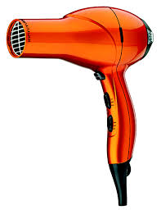

**In which picture can you see a cooker**?

* 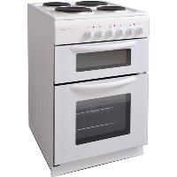
* 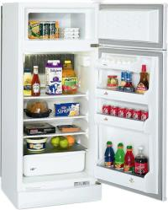
* 

Household appliances (definitions)  
By each definition write in the letter of appropriate name.

|  |  |  |
| --- | --- | --- |
| **Definition** | **Answer** | **Word** |
| With it you can cook many meals, using heat or gas |  | **C** Dryer |
| With it you can dry your hair |  | **B** Refrigerator |
| It stores food in cold temperature |  | **G**  Cooker |
| With it you usually make hot and crispy bread |  | F Dishwasher |
| With it you can wash multiple dishes simultaneously |  | **A** Toaster |
| With it you can store food which needs freezing temperature |  | **J  Freezer** |
| With it you wash clothes |  | **D Vacuum cleaner** |

Начало формы

|  |  |  |
| --- | --- | --- |
| With it you usually clean dust in the room |  | **E** Washing machine |

Use of household appliances  
**Complete sentences with the appropriate household appliance.**

**1.**Put the chicken in the  and let it roast for 45 minutes.

**2.**Could you get the  out and clean your bedroom?

**3.**Please put the saucepan on the  and cook meat for 5 minutes.

**4.**Throw your wet clothes in the  ,they should be ready in 20 minutes.

**5.**I will have to buy a new hair  ,because my old one yesterday burned out.

**6.**There is nothing better than having a   to make cleaning after a big dinner.

**7.**Many students in their rooms have  ,so that they can make quick pizzas and other fast food.

**8.**I bought 10 kilos of salmon and put it all into the  to keep it good until the party.

Space I  
**In which picture can you see a rocket?**

* 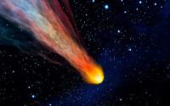
* 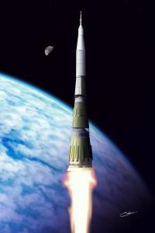
* 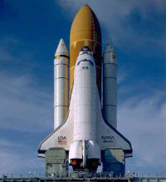

**In which picture can you see a space shuttle?**

* 
* 
* 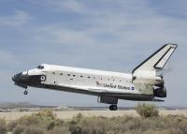

**In which picture can you see a space shuttle?**

* 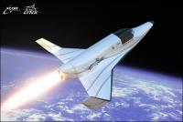
* 
* 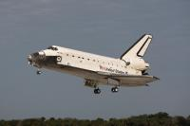

**In which picture can you see a rocket?**

* 
* 
* 

**In which picture can you see a telescope?**

* 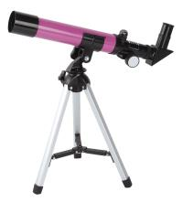
* 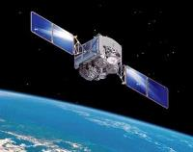
* 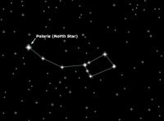

Space II  
In which picture you can see a satellite?

* 
* 
* 

In which picture you can see a galaxy?

* 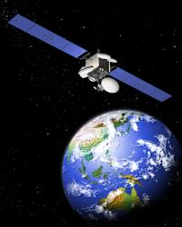
* 
* 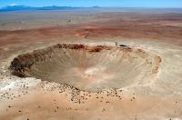

In which picture you can see the moon?

* 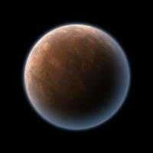
* 
* 

In which picture you can see a meteoroid?

* 
* 
* 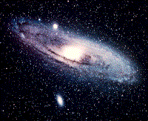

Space vocabulary definitions  
By each definition write in the letter of appropriate name.

|  |  |  |
| --- | --- | --- |
| **Definition** | **Answer** | **Word** |
| A person who is professionally educated and trained to go into space |  | **C** Meteor |
| An object, usually a rock, which has entered into the atmosphere and makes a bright line in the sky |  | **F** Astronaut |
| A huge object in the space, e.g. Earth, Saturn, Jupiter |  | **G**  Planet |
| A special tool which is used to look at the stars in the night |  | A Galaxy |
| A huge glowing object in the sky |  | E Telescope |
| A huge collection of stars |  | B  Star |
| A spacecraft which is used to travel into space and return back. |  | D Alien |
| An unknown creature from the galaxy, unknown race |  |  |

Use of space vocabulary  
**Write in the appropriate name from the Space vocabulary.**

**1.**The first person to step on the Moon was   Neil Armstrong.

**2.**I love nights, especially I love watching at the  . I find this planet so amazing.

**3.**Have you ever seen a   in the night? Like the Big Dog? And the Great Bear?

**4.**Usually a machine which is called  orbits in the space. They help to collect the data about the Earth.

**5.**Guess what! My dad bought me a   ! Come this evening to my place and we will look at the stars together!

**6.**  is reusable spacecraft. It flies into space and returns afterwards back.

**7.**I hate science fiction movies. Especially those where are involved  , those green people. They are very scary to me.

**8.**  is a space craft which is sent into the space to explore it.

**9.**Sun is not a planet, it is a   . Don't forget it.

Technologies Idioms  
**Choose the right idiom to complete the sentence.**

**1.**Did you see your mum a) hit the airwaves b) Light years ahead c) push the panic button ?  She was telling how she got the promotion at her company! You must be so proud of her!

**2.**Jane, can you please a) hold the wire b) push my buttons c) push the panic button? I need to take a paper where to write down what you are saying.

**3.**My brother sometimes can a) push my buttons b) hit the airwaves c) push my panic button and make me completely angry.

**4.**Their kid is always acting like he is a) hit the airwaves b) well-oiled machine c) driven by a motor. I have never seen so hyperactive kid!

**5.**Every time when there is a fire alarm, Silvia and Jessica a) push their buttons b) push the panic button c) hit the airwaves. They seem so frightened!

Reading.

The digital divide

Read through the text and answer the questions that follow – true or false.

**The Digital Divide**

A recent survey has shown that the number of people in the United Kingdom who do not intend to get internet access has risen. These people, who are know as 'net refuseniks', make up 44% of UK households, or 11.2 million people in total. The research also showed that more than 70 percent of these people said that they were not interested in getting connected to the internet. This number has risen from just over 50% in 2005, with most giving lack of computer skills as a reason for not getting internet access, though some also said it was because of the cost. More and more people are getting broadband and high speed net is available almost everywhere in the UK, but there are still a significant number of people who refuse to take the first step. The cost of getting online is going down and internet speeds are increasing, so many see the main challenge to be explaining the relevance of the internet to this group. This would encourage them to get connected before they are left too far behind. The gap between those who have access to and use the internet is the digital divide, and if the gap continues to widen, those without access will get left behind and miss out on many opportunities, especially in their careers.

**1.**More people in the UK do not intend to get internet access than before.

**2.**The minority of the people surveyed in 2005 weren't interested in having internet access.

**3.**Many people think that getting the costs down is the key to this problem.

**4.**The main reason for not getting internet access is the cost. **5.**The digital divide is widening in the UK.

The first computer programmer  
Read through the text and answer the questions that follow – true or false.

**The First Computer Programmer**

Ada Lovelace was the daughter of the poet Lord Byron. She was taught by Mary Somerville, a well-known researcher and scientific author, who introduced her to Charles Babbage in June 1833. Babbage was an English mathematician, who first had the idea for a programmable computer. In 1842 and 1843, Ada translated the work of an Italian mathematician, Luigi Menabrea, on Babbage's Analytical Engine. Though mechanical, this machine was an important step in the history of computers; it was the design of a mechanical general-purpose computer. Babbage worked on it for many years until his death in 1871. However, because of financial, political, and legal issues, the engine was never built. The design of the machine was very modern; it anticipated the first completed general-purpose computers by about 100 years. When Ada translated the article, she added a set of notes which specified in complete detail a method for calculating certain numbers with the Analytical Engine, which have since been recognized by historians as the world's first computer program. She also saw possibilities in it that Babbage hadn't: she realised that the machine could compose pieces of music. The computer programming language 'Ada', used in some aviation and military programs, is named after her.

**1.**Babbage programmed the first computer.

**2.**The Analytical Engine was electronic.

**3.**Babbage saw that his machine could write music.

**4.**Ada Lovelace's teacher introduced her to Charles Babbage.

**5.**Luigi Menabrea designed the first computer.

**6.**Babbage's design was ahead of its time.

**7.**Ada's work was instantly recognised as being the first computer program.

Computers and other technologies (dialogue)  
Read the dialogue and answer the multiple-choice questions that follow.

**Hooking Up My Computer**

Peter: Hi Jack. Can you give me a hand? Jack: Sure. what's up? Peter: I've just bought a new computer and I'm having some problems hooking everything up. Jack: ... and I'm a geek. Yeah, I know. I'd be happy to help. Peter: Thanks! I've connected all the cables from my monitor, mouse and keyboard, and I've plugged it in. Jack: Have you installed the software yet? Peter: No, I haven't. Do I need to? Jack: Not always, but it's best to install drivers for your keyboard and mouse, as well as your printer. Peter: Will the computer boot up without those? Jack: Of course. Boot up the computer and then we can update the drives. Peter: OK. What's that thing (points to a computer component) Jack: Oh, that's a memory reader. You can insert things like SD cards from your camera and mp3 players into it. Peter: That's handy. Jack: You've bought a nice system. How big is the hard drive? Peter: I think it's 750 gigabyte. Jack: Good... The computer's booted up. Let's install those drivers. Peter: Before we do that, can I get online? Jack: Do you have a modem? Peter: Yes, I do. I think I have a cable modem. Jack: hmmm... yes you do. Is the Ethernet cable plugged in? Peter: What's that? Jack: It's the cable that connects your modem to your computer. Peter: Let's surf the internet! Jack: Just a moment... first we need to launch the browser. Peter: The browser? Jack: It's the program that allows you to surf the internet. Peter: oh ... I've got a lot to learn. Jack: Yes, you do. I can see I'm going to be here all day ...

**1. Why does he ask Jack for help?**

- is friendly  
- is a geek  
- can’t say no

**2. What does Jack suggest Peter install?  
-** A new hard drive  
- Drivers for the keyboard, mouse and printer  
- A new browser

**3. Which hardware is required to get online?  
-** A cable modem and Ethernet cable  
- A cable modem and SD card  
- A cable modem and printer

**1. What's Peter having problems with?**Peter is having problems with  a) hooking up b) installing c) unplugging his new computer

**2. Which statement is true according to Jack?  
-** The computer will boot up, but new drivers will help.  
- The computer won't boot up without the new drivers.  
- The computer will boot up and new drivers won't help.

**3. Which software do they need to surf the internet?  
-** A SD card  
- A word processor  
- A browser

New Home Theater System (dialogue)  
Read the dialogue and answer the multiple-choice questions that follow.

**New Home Theater System**

Derek: Would you like to see my new home theater system?

Ken: I'd love to. I'm an audiophile - and I love HD TV.

Derek: Then you're going to love my system. I've got surround sound speakers, an incredible receiver, and a 52-inch flat screen LCD.

Ken: I'm green with envy! Put something on!

Derek: How about a movie? Something with lots of action. Let me just turn up the volume a bit...there. What do you think? (watching the movie)

Ken: That's amazing. The picture is so clear! Even when there is a lot of movement, the picture is hardly pixelated at all.

Derek: I know. Isn't it great? How do you like the sound?

Ken: Pretty good. It seems a bit muffled in the bass, though.

Derek: Just a second, I'll tweak the balance.

Ken: Ah, that's better. The bass is much more distinct now.

Derek: Isn't the color saturation superb?

Ken: I'll say it is. I bet golf looks incredible on this TV.

Derek: Ah, you appreciate golf do you?

Ken: I love watching golf on TV. Especially in high definition.

Derek: I think there may be a tournament on now. Just a sec, I'll switch to cable.

Ken: I think it's on channel 806.

Derek: Nope, not there. Let me change channels.

Ken: There, on 808. Wow! You can see the blades of grass.

Derek: I love this system!

Ken: What do you do if it's late at night? You can't listen to this system if your children are sleeping.

Derek: That's not a problem. I just plug my headphones into this jack. Problem solved.

Ken: Speaking of headphones, I bought a pair of earbuds for my mp3 player last week.

Derek: How are they?  
Ken: Pretty good. The bass isn't too bad, but the treble is crystal clear.

Derek: I need to get a new CD player for my system.  
Ken: Why? You can just put your CDs onto the DVD player, they'll play.

Derek: Really? I didn't know that.  
Ken: Come on, you're the proud owner of the latest home stereo system and you didn't know that?

Derek: I'm embarrassed.  
Ken: You should be!

**1. Which type of TV did he get?  
-** A flat screen LCD  
- A flat screen plasma  
- A surround sound TV

**2. What does Derek do to improve the bass?  
-** He turns it down.  
- He plugs the headphones into the jack.  
- He tweaks the balance.

**3. What does he say you can see when watching golf on this TV?  
-** The clear golf balls  
- The handsome players  
- The blades of grass

**4. What does Derek do if he wants to watch a movie late at night?  
-** He plugs the earbuds into the jack.  
- He doesn't watch movies late at night.  
-  He plugs the headphones into the jack.

**5. What did Derek get?  
-** A new computer  
- A new home theater system  
- A new mp3 player

**6. What does Ken say about the picture?  
-** It's very clear.  
- It's muffled.  
- It's fuzzy.

Bully for you

Read through the text and answer the questions that follow, true or false.

The makers of a controversial computer game about bullying have decided to go ahead and launch it despite calls for it to be banned. In the game, players take on the role of a new students at a school and have to fight the bullies, by punching them or hitting them with a baseball bat. Critics have said that the game encourages violence, but the makers deny this and say that, while there is violence in the game, it is just an amusing look at school life, besides which, the violence in the game is directed against the bullies to protect pupils who are being bullied. The makers also say that players will learn to stand up to bullies. A British politician, a former minister, has called for it to be banned as it might affect the way young people perceive violence. Anti-bullying charities have said that the game might make people respond violently to bullies, which might make things more complicated and result in injuries.

**1.**The makers of the computer game decided not to release it.

**2.**The politician used to be a minister.

**3.**The politician thinks it might make young people look at violence differently.

**4.**The game is set in a university.

**5.**The anti-bullying charity thinks that people might get hurt because of this game.

**6.**Everyone agrees that the game encourages violence.

Technologies

**Internet Addiction**

The latest addiction to trap thousands of people is the Internet, which has been blamed for broken relationships, job losses, financial ruin and even suicide.  Psychologists now recognize Internet Addiction Syndrome (IAS) as a new illness that could cause serious problems and ruin many lives. IAS is similar to other problems like gambling, smoking and drinking: addicts have dreams about the Internet; they need to use it first thing in the morning; they lie to their parents and partners about how much time they spend online; they wish they could cut down, but are unable to do so. Many users spend up to 40 hours a week on the Internet. Some of the addicts are teenagers who are already hooked on computer games and who find it very difficult to resist the games on the Internet.

"I cannot put down the phone, which is connected to the Internet. I am crazy about knowing what my friends and classmates are doing and where. It is really like an addiction", says Jessica Dawsy, a teenage girl from Texas. " My brother is also an addict, but he loves to play video games. If I forbid him to play them for one evening, he gets angry and very aggressive. I do not know how to help him."

Scientists claim that family is the biggest support and can help the teenagers the most. They need to pay attention more to them and  offer various activities, such as sports, music lessons and other hobbies.

**Match if these statements are true or false or there is no such information in the text** (true, false, doesn’t say)**:**

**1.**Scientists say that school has to help teenagers with Internet addiction.

**2.**According to the text, addict's family should communicate more with him and propose him to take up hobbies. **3.**IAS is similar also to having an addiction of drugs.  
**4.**According to the text, Jessica's brother while playing video games gets more aggressive.  
**5.**Jessica Dawsy brother is addicted to Internet less than Jessica is.

**Answer to the following questions:**

**1.**What is Jessica addicted to?  
**2.**What is the full name of IAS?  
**3.**To what is addicted Jessica's brother?

Beginning of space exploration

**Beginning of space exploration**

Humans have dreamed about spaceflight since antiquity. The Chinese used rockets for ceremonial and military purposes centuries ago, but only in the second half of the 20th century were rockets developed that were powerful enough to overcome the force of gravity to open space to human exploration.  
  
As often happens in science, the earliest practical work on rocket engines designed for spaceflight occurred simultaneously during the early 20th century in three countries by three key scientists: in Russia, by Konstantin Tsiolkovski; in the United States, by Robert Goddard; and in Germany, by Hermann Oberth.  
  
The first U.S. satellite, Explorer 1, went into orbit on January 31, 1958. In 1961 Alan Shepard became the first American to fly into space. On February 20, 1962, John Glenn’s historic flight made him the first American to orbit Earth.  
  
“Landing a man on the moon and returning him safely to Earth within a decade” was a national goal set by President John F. Kennedy in 1961. On July 20, 1969, Astronaut Neil Armstrong took “a giant step for mankind” as he stepped onto the moon. Six Apollo missions were made to explore the moon between 1969 and 1972.  
  
By the early 1970s orbiting communications and navigation satellites were in everyday use, and the Mariner spacecraft was orbiting and mapping the surface of Mars. By the end of the decade, the Voyager spacecraft had sent back detailed images of Jupiter and Saturn, their rings, and their moons.

**Match if these statements are true or false or there is no such information in the text** (true, false, doesn’t say)**:**

**1.** Japan in 20th century also actively participated in Space exploration.  
**2**. John Glenn went into American history as the first who orbited Earth.  
**3.**Russia, United States and Germany were the main competitors in 20th century in Space exploration.  
**4**. Explorer went into orbit in 1950s.  
**5.**Chinese utilized rockets only for military actions.  
**6**. Neil Armstrong was the first American to fly into space.

**Answer to the following questions:**

**1.**Which spacecraft explored Mars in 1970s?  
**2.**How many Apollo missions were made between 1969 and 1972 in order to explore the moon? Конец формы

Space shuttle

**Space shuttle**

In April 1981 the launch of the space shuttle Columbia ushered in a period of reliance on the reusable shuttle for most civilian and military space missions. Twenty-four successful shuttle launches fulfilled many scientific and military requirements until January 1986, when the shuttle Challenger exploded after launch, killing its crew of seven.  
  
The Challenger tragedy led to a reevaluation of America’s space program. The new goal was to make certain a suitable launch system was available when satellites were scheduled to fly. Today this is accomplished by having more than one launch method and launch facility available and by designing satellite systems to be compatible with more than one launch system.  
  
The Gulf War proved the value of satellites in modern conflicts. During this war allied forces were able to use their control of the “high ground” of space to achieve a decisive advantage. Satellites were used to provide information on enemy troop formations and movements, early warning of enemy missile attacks, and precise navigation in the featureless desert terrain. The advantages of satellites allowed the coalition forces to quickly bring the war to a conclusion, saving many lives.  
  
Space systems will continue to become more and more integral to homeland defense, weather surveillance, communication, navigation, imaging, and remote sensing for chemicals, fires and other disasters.

**Match if these statements are true or false or there is no such information in the text** (true, false, doesn’t say)**:**

**1.**Nowadays there is more than one launch method to avoid future space disasters.  
**2.**Satellites in Gulf War helped to give data of different objects.  
**3.**Space systems will help people to gather data about weather, communicate and predict different disasters.  
**4.**There were more than 30 shuttle missions until 1986.  
**5.**One of the advantages of satellites is that there are small and not so visible.  
**6.**Gulf War established the importance of employees in Space field.

**Answer to the following questions:**

**1.**Which event proved the value of satellites in nowadays issues?  
**2.**When was the first launch of shuttle Columbia?